The City of Albuquerque is teaming up with SeeClickFix. By downloading the “ABQ311” Mobile App to your iPhone or Android device, or using the Self-Service at www.seeclickfix.com/albuquerque/report, citizens will be able to report 311, non-emergency issues. If the issue address is within the City of Albuquerque, it will be interfacing with 311’s CRM application, and issues will be responded to in the same manner as dialing 311.

Creating a case is divided into 3 separate steps.
A. Location.
B. Add Photo (optional)
C. Issue

Click on the “Report” button on the screen

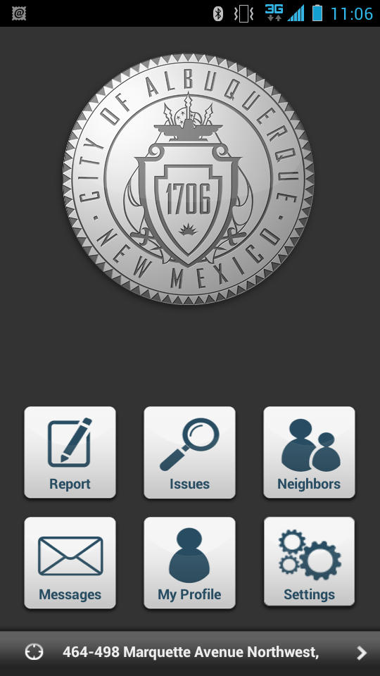

A. Location. This can be done 3 different ways.

Note: Click on “Location” on Touch Screen.
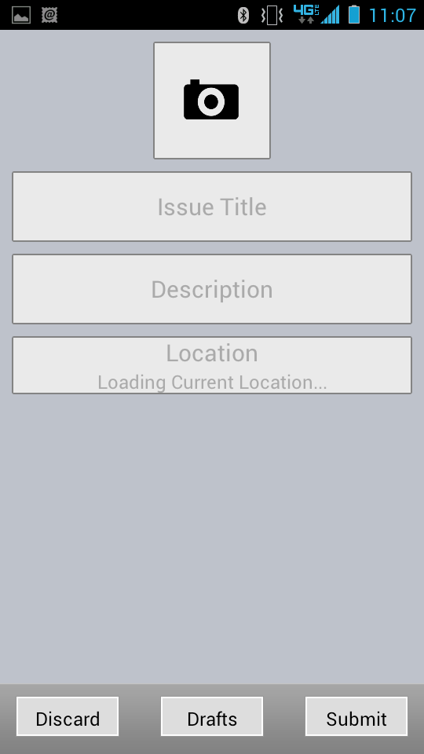

- The first way by default, it will pick up your current location.
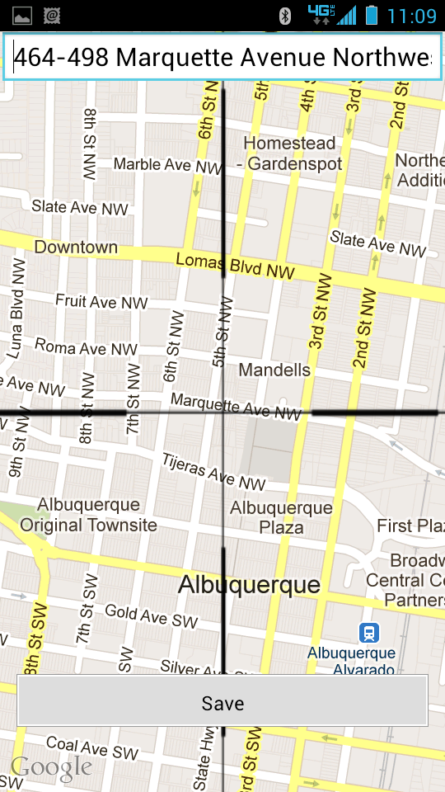

2. The second way to report an address location is by sliding the cross and dropping the pin to the location you want your issue reported. 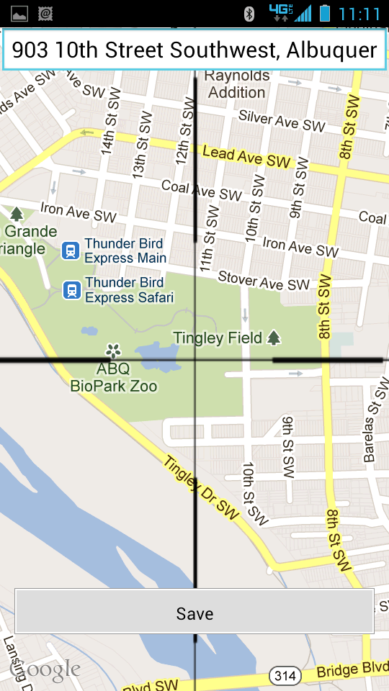

3. The third way to report an address is to type in the address in the search box.

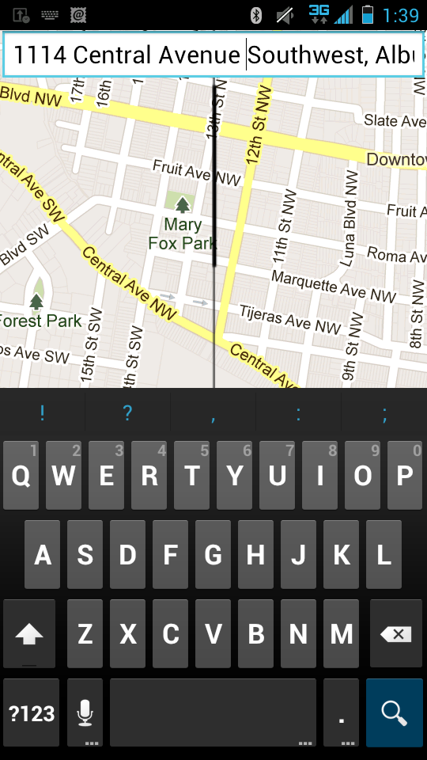

B. Add a Photo – (optional)

- Click the camera icon on the touch screen
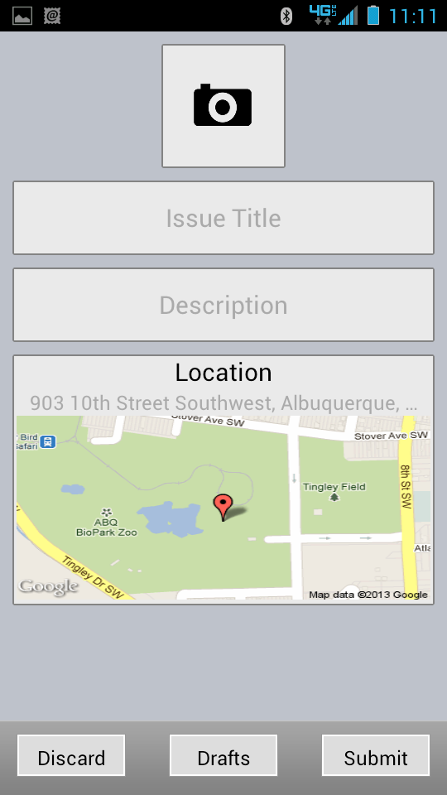

- Choose “From Camera” if you are going to snap a picture. If you took a picture prior to logging the case, choose from Photo Gallery.
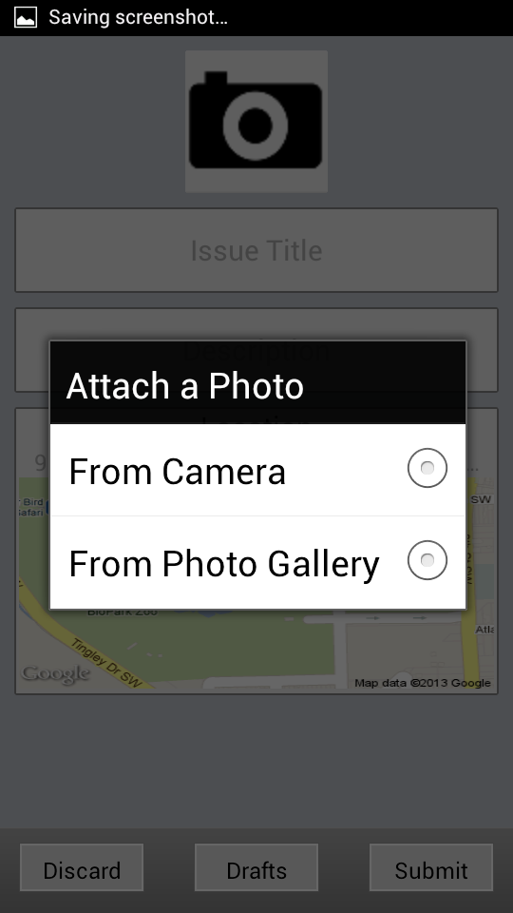

(Your Picture here)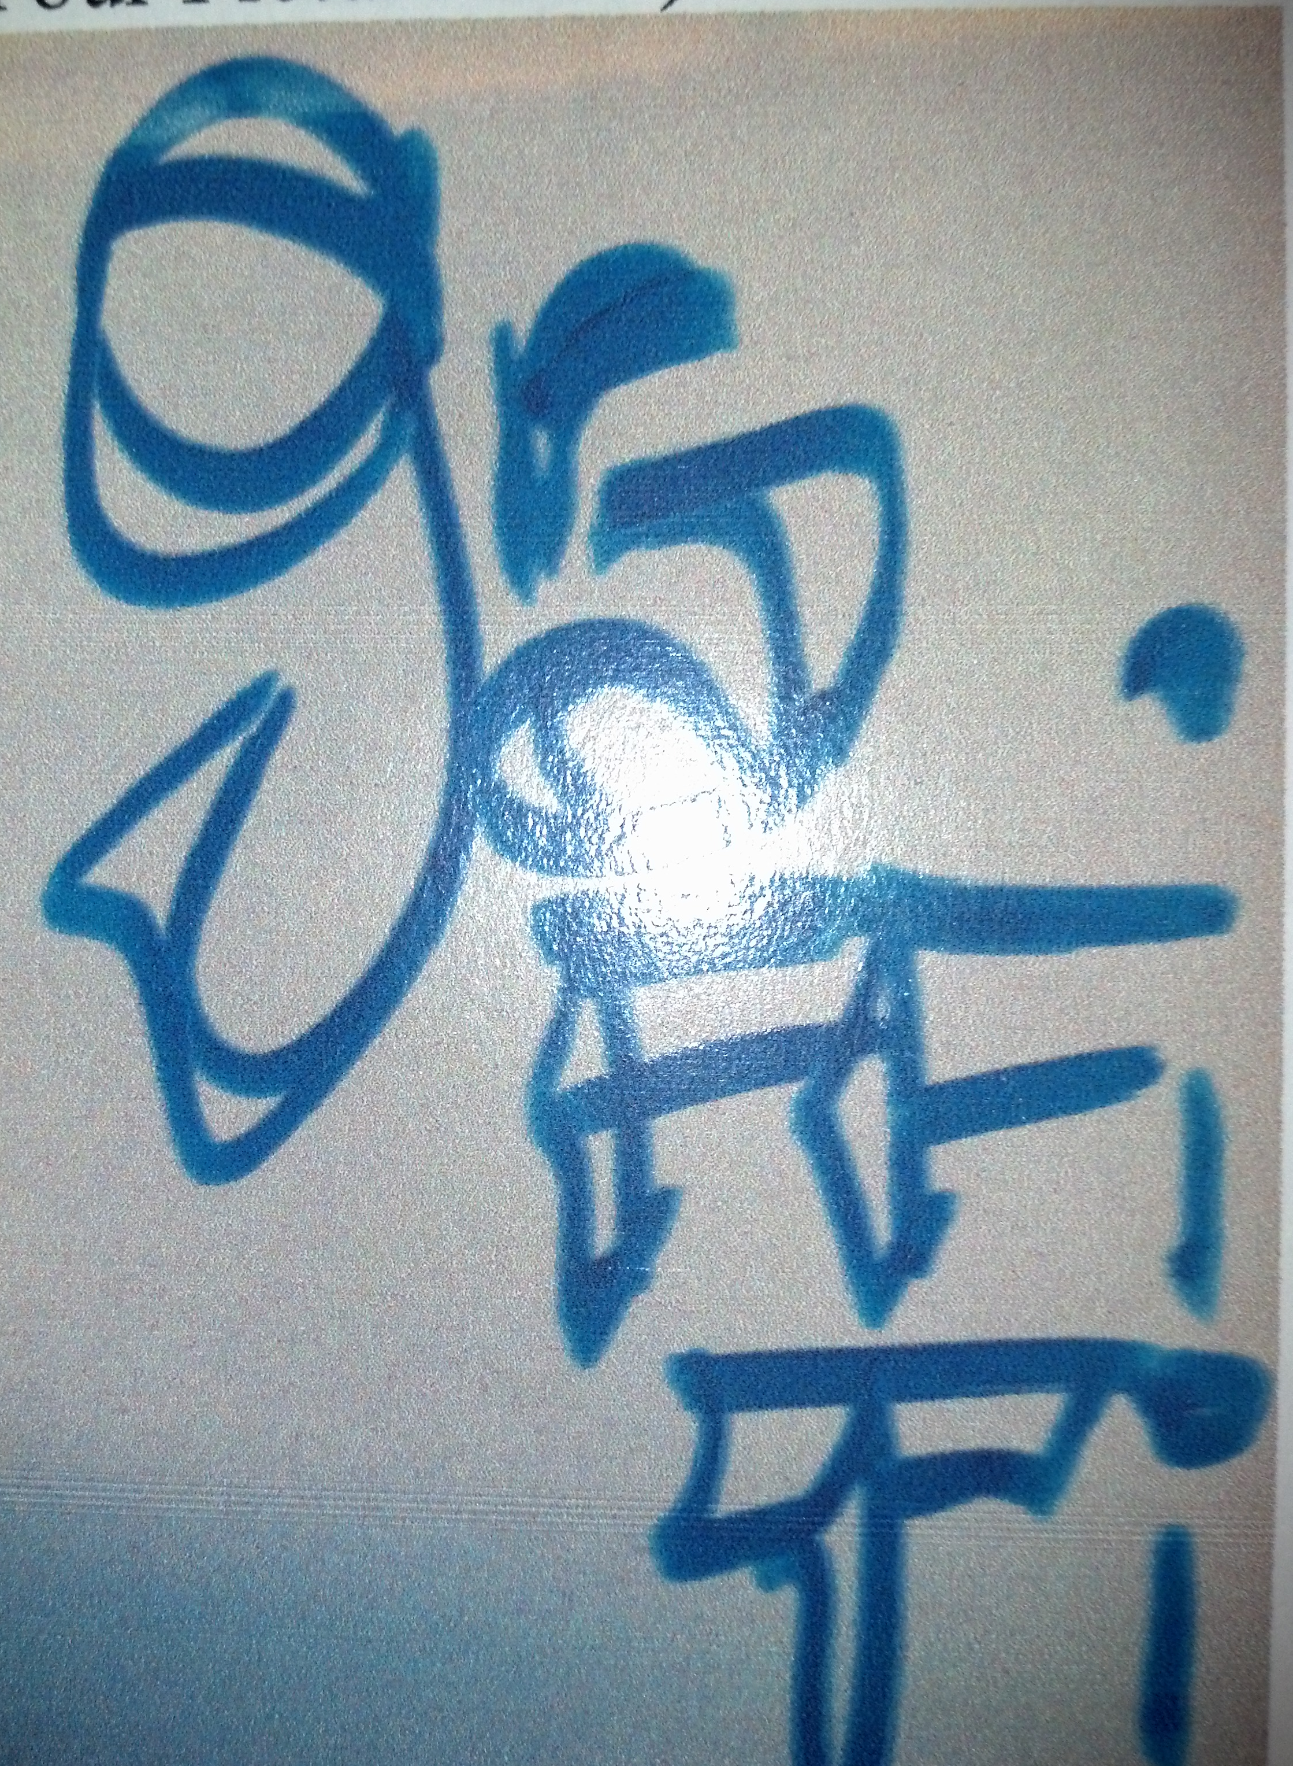
3. Click the Checkmark to select the photo. This takes

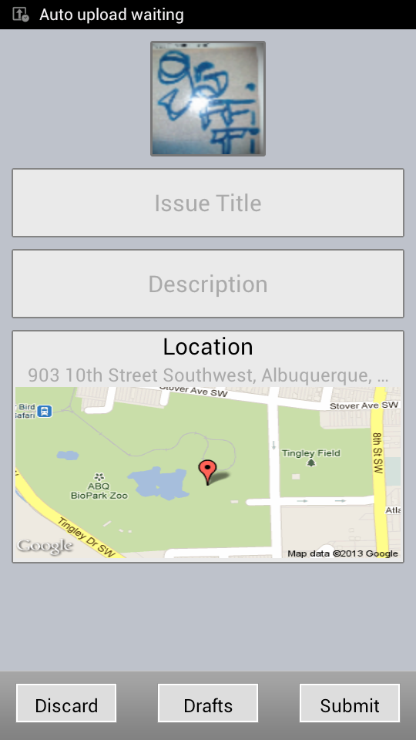

C. Report the Issue

1. Click “Issue Type” on your touch screen.

2. Choose one of the City’s Top Requests listed in the drop down.
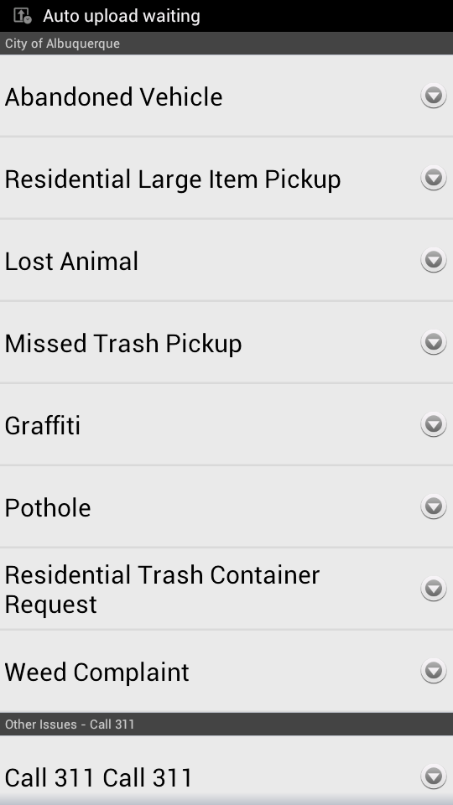

- Click on Description
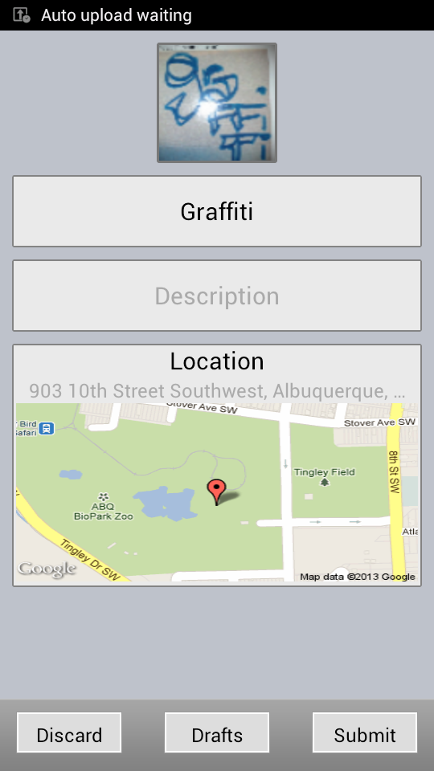

- Follow the Prompts
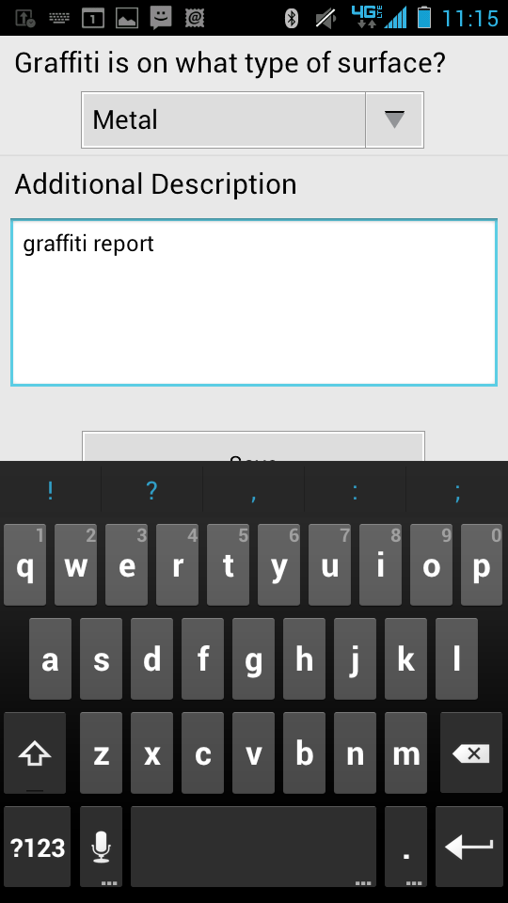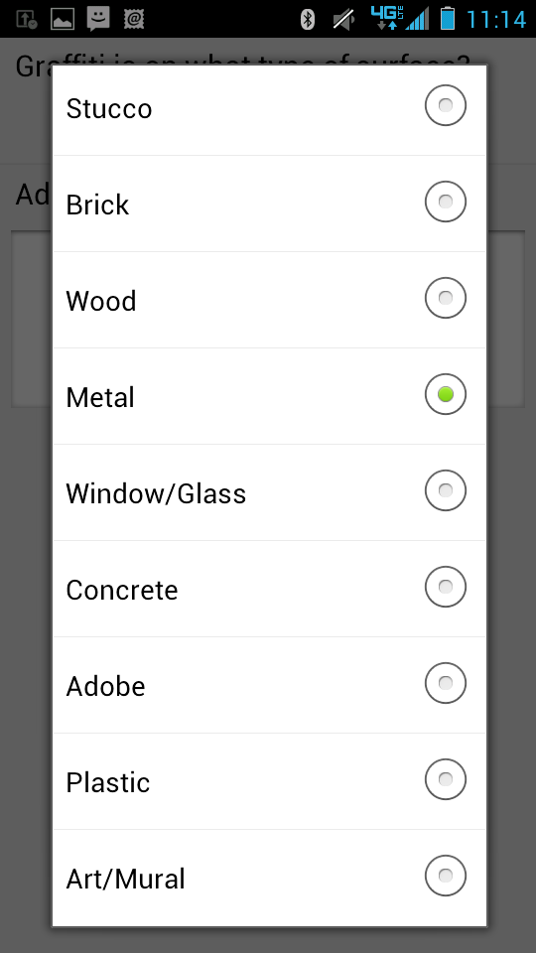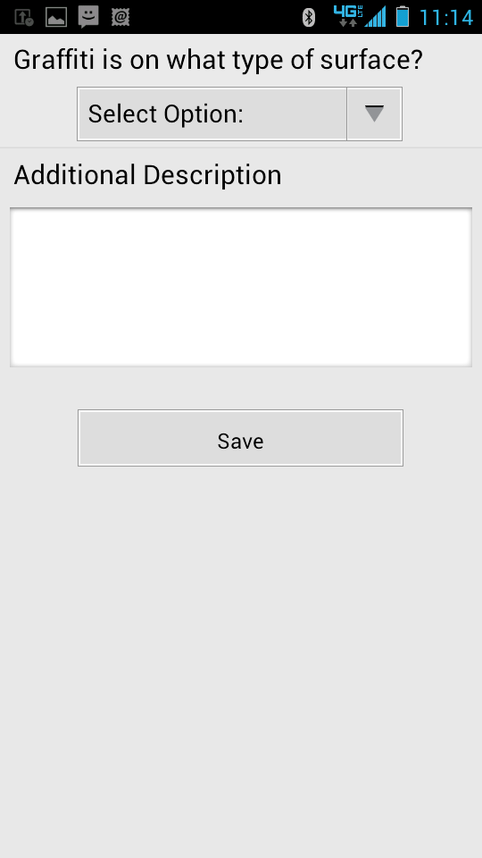

5. Click Save
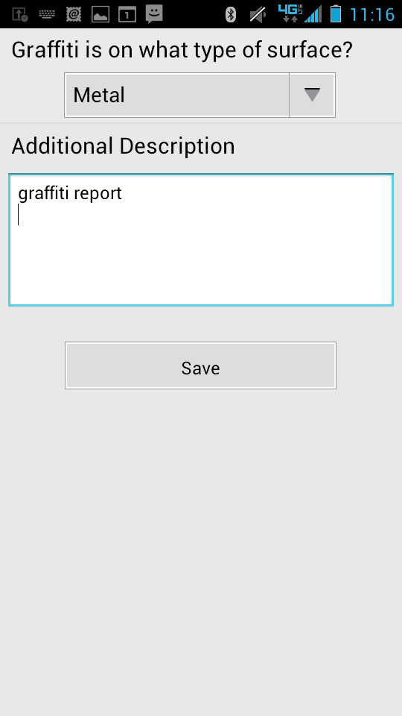

- Click Submit
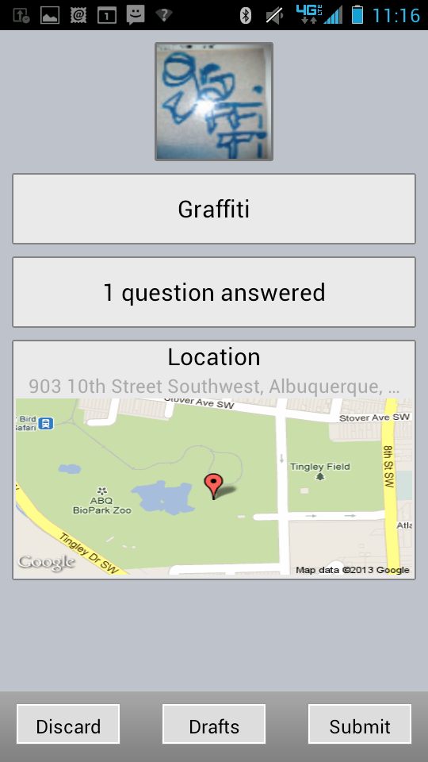

7. Click Submit again.
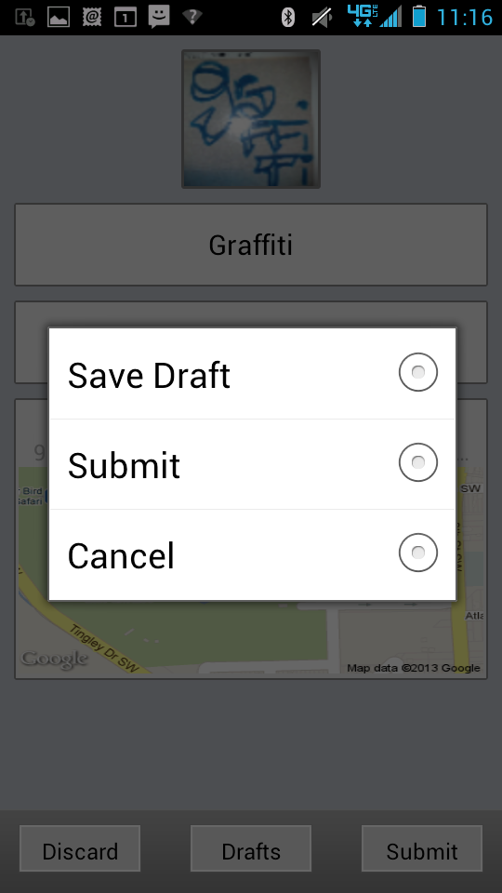

Your case is now submitted.

